Journey to the Death Railway

23 March 1943: A survivors account of how even being transported up to the area where they were forced to work was an appalling ordeal for Allied POWs
MAR 23

SAVE |  | ▷ LISTEN

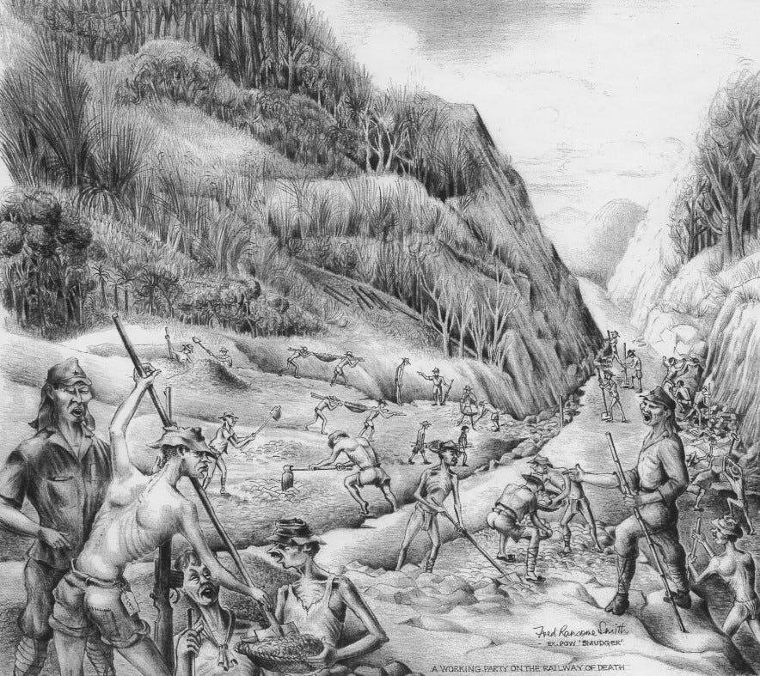
‘A Working Party on the Railway of Death’, Fred Ransome Smith, former prisoner. Typical labouring scene. Shows Hammer and Tap, Embankment labouring, Timber felling and an excavated cutting.
Thousands of men were already working, and dying, on the 'Railway of Death', the Burma Thailand railway that the Japanese were building using POWs as forced labour.
The Japanese demand for labour was insatiable, which they addressed by bringing in more and more men from the prison camps in Singapore.
The railway journey through Malaya up to the work camps in Thailand was the first ordeal that these men faced. It was an experience that no man would forget and a number of memoirs record its horrors. John Wyatt¹ was one of them:
Our force was given the letter D, and on the 23rd we were herded onto lorries and driven to Singapore railway station. Sitting at the platform was an antiquated engine, attached to a series of metal cattle trucks around 20 feet long by 7 feet wide and 7 feet in height.
We were unceremoniously crammed into these metal boxes, thirty men to each truck, and my basic maths worked out that we had around 5 square feet each (even without kit it would have been a real crush). The trucks had central sliding doors on one side only and I dreaded the thought of the journey that was to come.
It took us quite a few minutes to get organised but by sitting on top of our kit we were able to make ourselves as comfortable as possible. It was late in the afternoon when the train pulled out of Singapore station and crossed the causeway heading north. Before leaving Changi we had been given some tins of bully beef from Red Cross supplies and this is all we had to eat for the next twenty hours until the train pulled into Kuala Lumpur, at around l400hrs on the twenty-fourth.
One thousand miles in a ‘train’ that was simply hell on earth; at least two of the lads died and we had no option but to toss their bodies out of the doorway without as much as a prayer while the train rattled along northwards.
Sleep had been virtually impossible; none of us could lie down as we were packed so tightly together. The journey had been simply horrific. At Kuala Lumpur we were given a meal of weak stew and rice and very little water. I dreaded getting back into that steel box but after an hour or so we were ordered back on board.
At Ipoh we made another brief stop for a small meal of rice, but the main problem now was not food but lack of water - I was constantly thirsty. The train plodded on at a slow pace through the second night, reaching Bukit Mertajam Jetu around nine o’clock in the morning of the twenty-fifth and then on to Prai, where we were allowed off to stretch our legs.
Again we got the obligatory rice and weak stew before moving on again through Alor Star and on towards the Thai border. It was strange to be passing through the point in Malaya where it had all started for the Surreys almost a year earlier, when we had been free men preparing to meet the enemy.
By the third morning, the train steamed across the border into Thailand and we all hoped that we were nearing our final destination. Dysentery cases weren’t allowed off often enough and there was excrement everywhere; we simply wallowed in our own (and other people’s) shit and piss for four days and nights.
It was baking hot during the day and bitterly cold by night, and by now dysentery had got a grip on many of the lads. As each day in those horrific wagons passed we prayed that it was the end of the line and I said a silent prayer when the guards finally shoved us out of the trucks for the last time at Ban Pong, about forty miles west of Bangkok.
One thousand miles in a ‘train’ that was simply hell on earth; at least two of the lads died and we had no option but to toss their bodies out of the doorway without as much as a prayer while the train rattled along northwards.
We were loaded into trucks and driven a short distance to a large open space near the station where we were ordered to form up for inspection. No matter how bad the situation, the British soldier will always lift himself to his full height and form up in rank formation, and although we didn’t feel like it, this is what this ragtag group of soldiers did.
I for one was going to show the japanese that no matter how badly they treated me I would remain disciplined and never lose my dignity
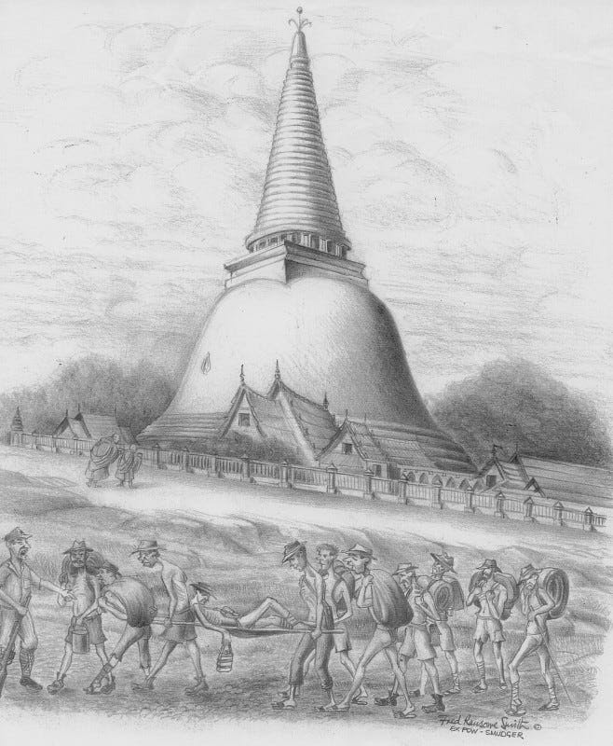
PHRA Pathom Chedi “Tallest Buhhdist Monument in the World” Monks and POWs in foreground. Fred Ransome Smith.
1
See John Wyatt: No Mercy from the Japanese: A Survivor's Account of the Burma Railway and the Hellships 1942-1945
For more sketches see Prisoners of War of the Japanese, which has a collection of materials, including many memoirs. This site has special emphasis on the experiences of Australian Medical Officers who did the their best, under appalling conditions, to help the sick and injured who were forced to work on the railway.
Britain at War has much more on the Railway of Death

